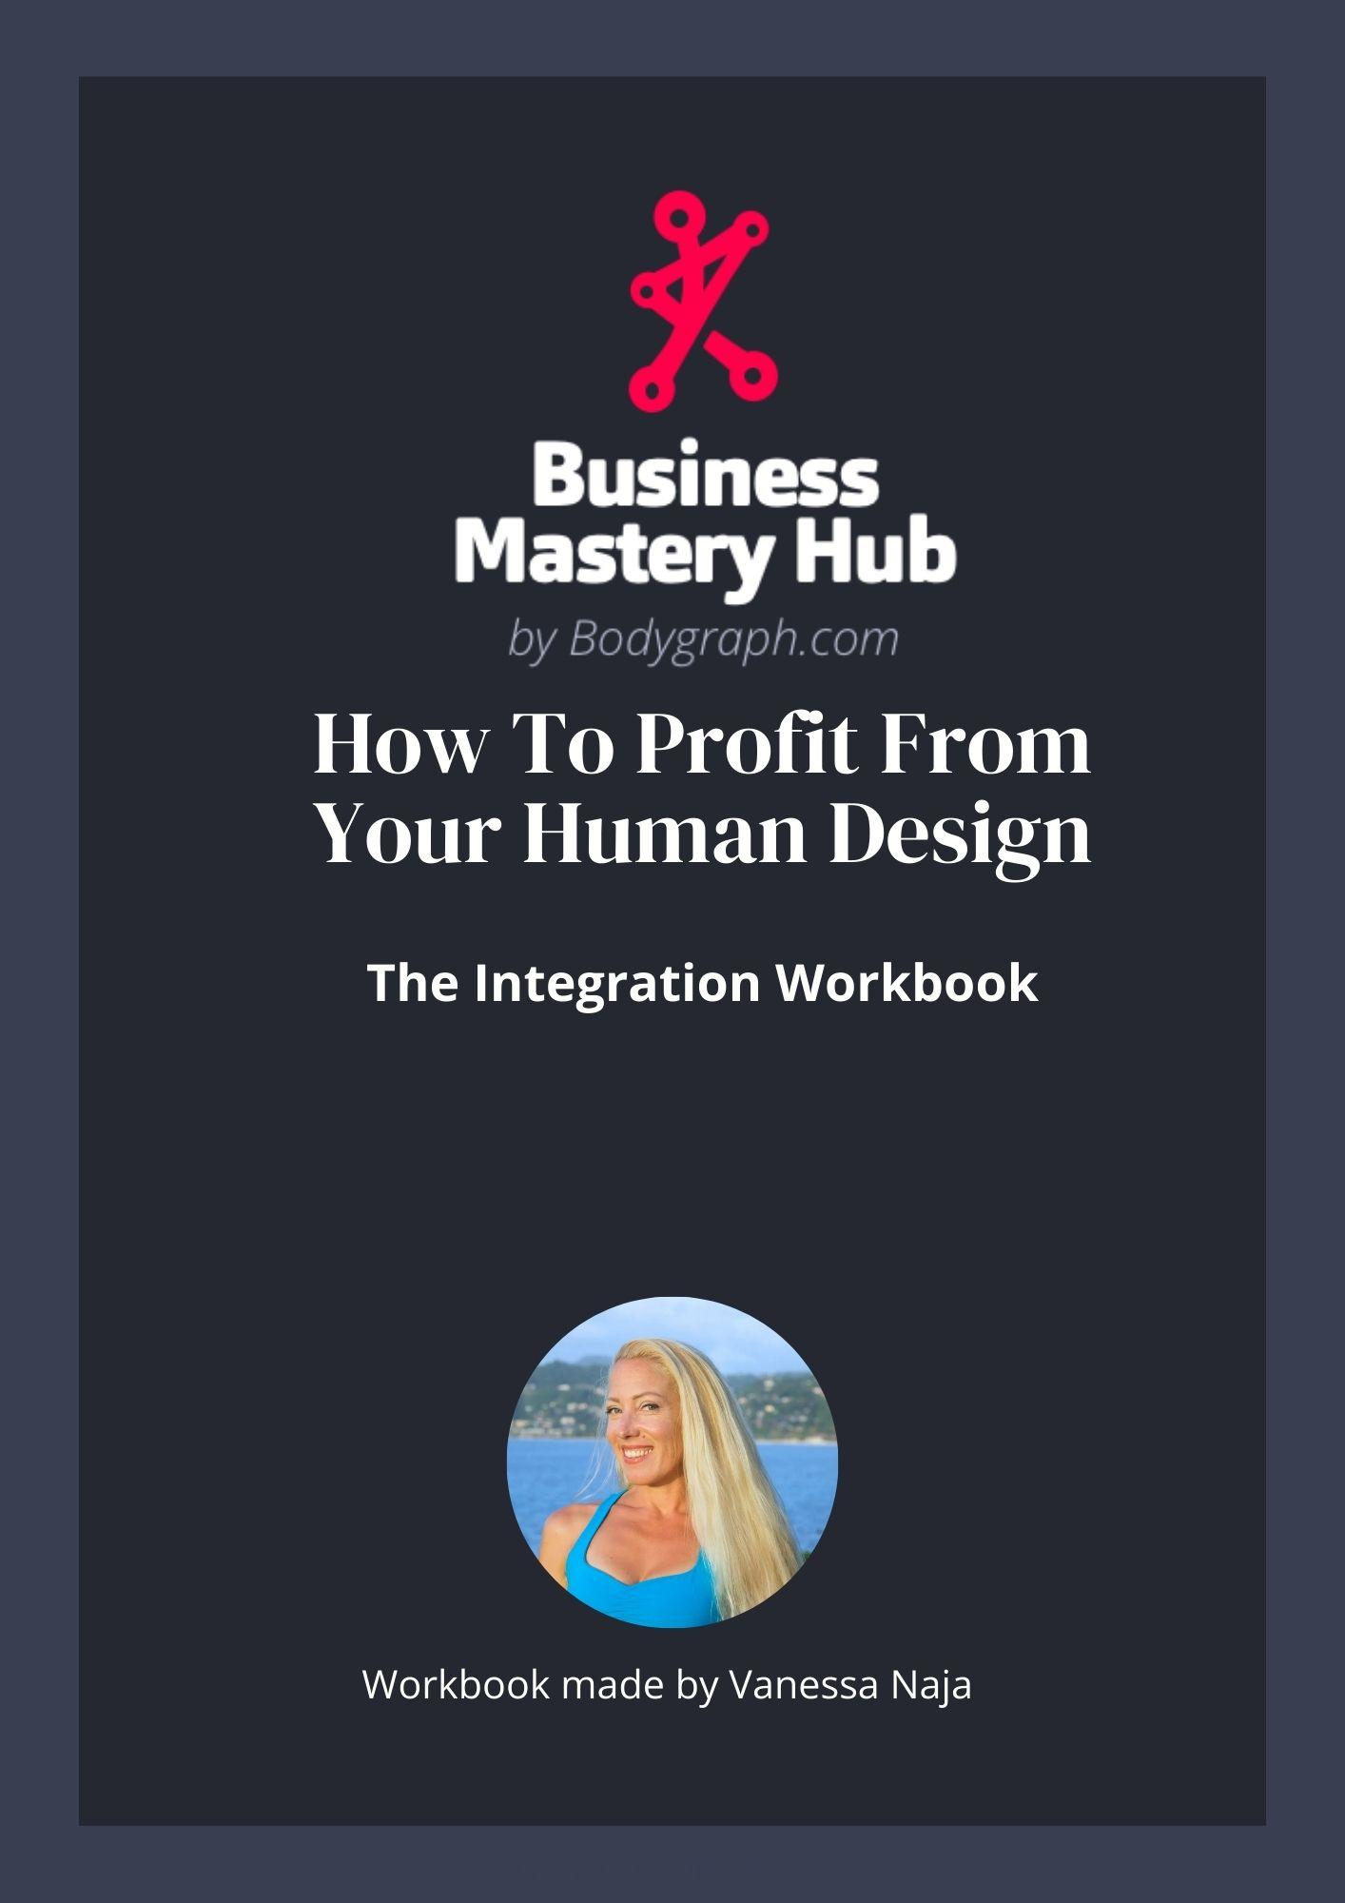

The Dance: Definition & Openness
Profiting from your design requires:
- Your defined centers operating in a healthy way
- Your undefined centers operating as wisdom instead of shadow
Your definition is how you consistently deliver your value.
Your openness is how you develop the wisdom people actually want.
Profit happens when:
- Strategy & Authority make the decisions
- Undefined centers integrate experience into wisdom
- Defined centers broadcast that wisdom clearly
Before going deeper, reflect:
- Where in my business does my delivery feel steady and consistent?
- Where in my business has lived experience influenced my perspective?
- Where might there be a gap between what I’ve lived and what I’m communicating?

Defined Centers: Healthy & Unhealthy Expression
Your defined centers determine how you consistently broadcast and deliver your value.
When defined centers are healthy, what you broadcast is clear and others receive it easily.
When defined centers are unhealthy, your broadcast becomes distorted and misunderstandings happen.

Healthy Expression of Defined Centers
Head – consistently experiences inspiration pressure and uses it as fuel for creative thinking
Ajna – steady, reliable ways of thinking and offers consistent mental frameworks
Throat – expresses energy naturally and impactfully when aligned, speaking or acting with consistent voice and timing
G-Center – stable sense of identity and direction without seeking external confirmation
Ego/Will – makes reliable commitments, understands its limits, and uses willpower strategically rather than constantly
Solar Plexus – honors emotional waves, waits for clarity, and communicates feelings with maturity
Sacral – responds to life with sustainable life-force energy and knows when to commit or disengage
Spleen – reliable intuitive awareness and instinctively knows what is healthy or unsafe in the moment
Root – handles pressure steadily and uses stress as motivational fuel without panic

Unhealthy Expression of Defined Centers
Head – addicted to mental pressure, obsessively chasing answers or trying to resolve questions
Ajna – rigid, argumentative, attached to being mentally right
Throat – forces expression for attention or control, over-talking or expressing at the wrong time
G-Center – over-identifies with a fixed self-concept, resists evolution or clings to outdated direction
Ego/Will – overpromises, competes unnecessarily, burns out trying to prove worth
Solar Plexus – reacts impulsively at emotional highs or lows, makes decisions without clarity
Sacral – says yes to the wrong things, overworks, becomes chronically frustrated from misused energy
Spleen – ignores intuition, becomes ruled by subtle fear patterns
Root – creates unnecessary urgency, rushes decisions, operates in chronic stress

Application
Choose 1or more of your defined centers and.
Reflect:
- When this center is operating in its healthy expression, how does that change how I show up in my work?
- When this center shifts into its unhealthy expression, what specifically changes in my behavior?
- How does that distortion affect the way I communicate my value?

Undefined Centers: Shadow & Wisdom
Your undefined centers are where you learn from lived experience.
They are most prone to conditioning and also where wisdom is formed over time.
Shadows and distractions speak to us through our mind and cause us to abandon our inner authority and make mind based decisions.
When Strategy & Authority make decisions, undefined centers integrate experience and operate as wisdom.

Shadow / Distraction in Undefined Centers
Head – Thinks about things that don’t matter, feels pressure to answer every question, mentally solves problems that aren’t theirs
Ajna – Tries to appear certain or mentally fixed to avoid feeling unstable or “not knowing”
Throat – Speaks or acts to attract attention or prove relevance when inappropriate
G-Center – Searches for love, direction, or identity through others and feels lost without external validation
Ego/Will – Overcompensates to prove worth or value, makes promises it can’t keep
Solar Plexus – Avoids conflict, suppresses feelings, or becomes overwhelmed by amplified emotional energy
Sacral – Tries to keep up with defined sacral energy, overcommits, exhausts themselves trying to match others energy
Spleen – Holds onto people, jobs, or situations out of fear of letting go
Root – Rushes to relieve pressure, makes impulsive decisions to reduce stress

Wisdom in Undefined Centers
Head – Knows which questions are worth engaging and what is truly inspiring
Ajna – Comfortable with uncertainty and able to see multiple perspectives without attachment
Throat – Understands timing deeply and speaks with precision when recognized
G-Center – Masters environment and relationships, recognizes that place and people determine alignment
Ego/Will – Understands that worth is inherent and discerns which commitments are truly aligned
Solar Plexus – Emotionally intelligent, able to read and navigate others’ emotional states without drowning in them
Sacral – Understands personal energy limits and becomes skilled at guiding or managing sustainable output
Spleen – Deeply attuned to subtle health patterns and senses what is safe and healthy for others
Root – Recognizes that pressure is environmental and does not let stress dictate timing or choices.

Application: Shadow → Decision → Wisdom
Choose 1 or more undefined centers that tend to activate in your business.
Using the shadow description:
- What specifically triggers this in my work?
- What thoughts show up when this shadow activates?
- What kind of decisions does it push me toward?
When this shadow is active, is my mind trying to:
- Convince me?
- Create urgency?
- Prove something?
- Relieve discomfort quickly?
Shadows drive mental decision-making and pull you away from Strategy & Authority.
Now shift to the wisdom expression:
If I paused and allowed my Strategy & Authority to lead instead:
- How would this same center operate differently?
- How would my decisions change?
- How would my communication change?

Strategy & Authority: Real-Time Decision Awareness
This whole workshop comes back to one thing: How are you making your decisions?
Defined centers express in a healthy or unhealthy way, undefined centers operate as shadow or wisdom, and the difference comes down to decision-making.
When a shadow is at play, it creates pressure, urgency and a mental story and if you follow that story the shadow drives the outcome.
Think about a current decision in your business and notice what your mind is doing. Is it trying to convince you, building a case, creating urgency, trying to secure certainty or relief?
Now shift your attention to your authority.
Does the decision feel clear in your body? Is there a clear felt sensation that lets you know it is or is not correct for you? Does it feel embodied rather than mental?
Where in your business does shadow most often step in and drive your decisions?
Name that pattern clearly, because awareness in that moment is the practice.
Start to check for that pattern whenever you’re making decisions. Noticing it and returning to felt sensation in the body to make decisions is key.

Communicating Value & Aligned Profit
You profit from how you communicate your value.
Your value is the wisdom formed through your undefined centers, expressed through your defined centers.
Choose one current offer, service, or piece of messaging.
Now answer directly:
- What specific lived experience gives me authority in this area?
- Where am I clearly communicating that embodied wisdom?
- Where am I leaning on information instead of lived perspective?
Look at your delivery.
- Is my defined energy expressing this wisdom in a healthy way?
- Or is distortion influencing how I show up, speak, price, or position it?
If I were fully aligned in this offer or message:
- What would I say differently?
- What would I stop over-explaining?
- Where would I trust my outer authority instead of trying to convince?
Aligned profit includes your signature theme of satisfaction, peace, success or surprise/delight. It feels grounded rather than pressured.
Choose one specific change you will make to how you communicate this offer.
Ongoing Practice
Your shadows & distractions will come up and when they do your mind will start building a case, create urgency, try to convince you or rationalize your decisions.
When you’re aware and notice the moment the mental story starts running, you can stop the pattern. Instead of letting the mind decide, you pause and return to your authority.
As you move forward, pay attention to the specific shadows that show up most often in your business. Notice what activates them, notice what they try to make you do, and notice how different it feels when your authority decides instead. Always ask yourself, “is this my mind deciding or is it my authority?”.
This is how shadows turn into wisdom, true outer authority forms and you’re consistently able to articulate and deliver value.

