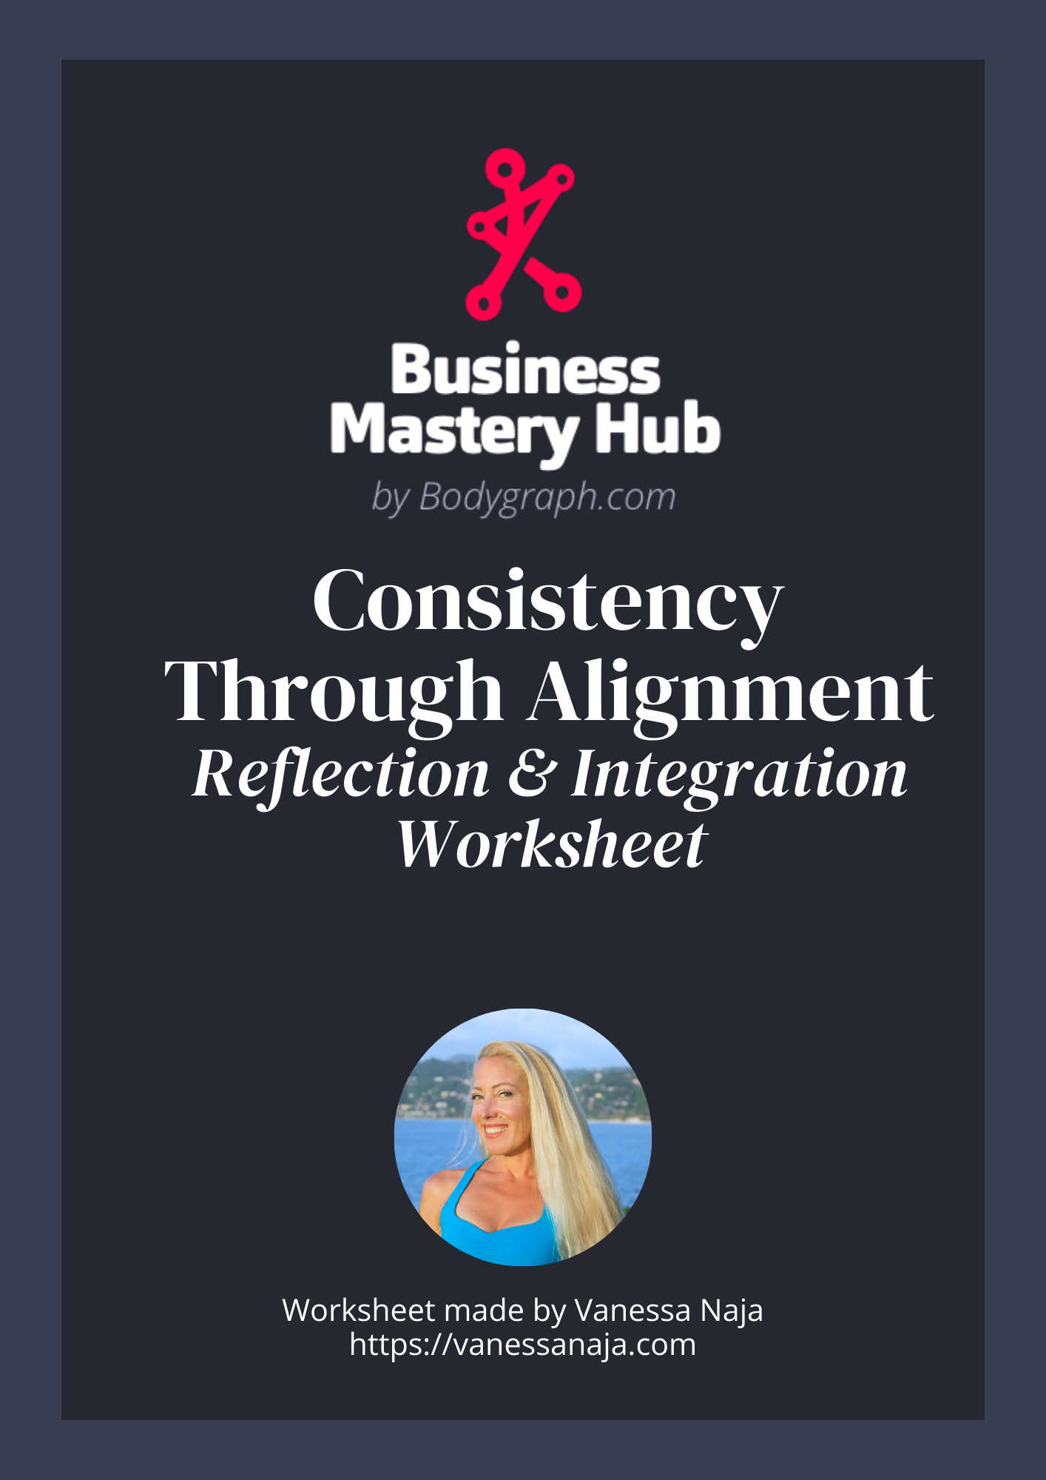

Consistency Through Alignment
A post-workshop integration guide for anchoring your natural rhythm, identifying misalignment, and returning to alignment.

Your Consistency Begins With Alignment
You can only create sustainable consistency when the work itself is aligned with your Strategy and Authority.
- What area of your business feels hardest to be consistent in?

- Why did you choose this area? What feels heavy, forced, or draining about it?

- How did you originally decide to use this particular platform, business strategy, marketing style or method? (Notice where conditioning may have influenced your choices.)

- Where do you already suspect misalignment? (the first thing that comes to mind is usually it

PART ONE: Rhythm Through the 5-15 Channel

Teaching Reminder: Your Rhythmic Design
Gate 5: natural consistency in specific areas where it is correct.
Gate 15: rhythmic extremes, seasonality, environmental influence.
Channel 5–15: embodied rhythm that others sync to.
Undefined 5–15: you learn rhythm through others and environments.

Rhythm Reflection
- How does your rhythm actually feel in your daily life when you're not forcing it?

- Where do you feel most naturally consistent or patterned? (even if it seems small or unrelated to business)

- Where does your rhythm swing, stretch, or move in cycles?

- Where have you tried to force yourself into a rhythm that doesn’t match your design?

- How do environments or people influence your timing, energy, or flow? (particularly important for Gate 15 or undefined rhythm)

6. When you look at the area you chose earlier, are you trying to:
- make Gate 5 rigid across everything,
- make Gate 15 predictable,
- or make undefined rhythm fixed?

PART TWO: Variables and Your Consistency

Teaching Reminder: Your Operating System
(Variable directions change frequently and so require a very accurate birth time)
BodyGraph = your hardware. It shows what energy is consistently available.
Variables = your operating system. They show how your mind and body naturally process life.
Two people can have the exact same chart but behave completely differently because their Variables give them different operating styles.

Summary of Variable Orientations
Left-Dominant: structure, repetition, clarity, predictable systems.
Right-Dominant: rhythm, environment, inspiration, non-linear, trust-based.
Balanced: a blend of the two with light structure and flexible flow.

Variables Reflection
- Describe how you naturally process information. (left-dominant, right-dominant, or balanced processing style)

- Where in business have you been trying to operate in the opposite style?

3. How does forced focus or forced flexibility feel in your body?

- What kind of consistency does your design actually need? (predictable structure, natural waves, or a mix of light structure plus flexibility)

- What would feel more natural, sustainable, or easeful if you leaned into your true processing style?

Integrating Rhythm + Variables
- Where does your rhythm style (5–15) complement your Variable orientation?

- Where do they clash or create confusion?

- When you zoom out, what does “aligned consistency” look like for someone with your combination?

Identifying Misalignment
- What does forced consistency look like for you?

- What does aligned consistency feel like in your body?

- Where have you been trying to be consistent in a way that goes against your Variable orientation?

- Where have you been trying to override your natural rhythm style (fixed, extreme, undefined)?

- What signals show up in your body that tell you something isn’t aligned?

Coming Back Into Alignment
- What is the most obvious place you’ve been operating from conditioning instead of alignment?

- What would aligning this area with your Strategy and Authority actually look like?

- What would you do differently today if you trusted your design instead of forcing consistency?

- What areas in your business can you let go of because you now realize they’re not in alignment, and where can you put your attention instead?

Closing Integration
- What old idea about consistency no longer aligns with your natural way of working?

- What aligned truth about consistency do you want to anchor moving forward?

- If you were already living in your natural consistency style, what would feel different?

- What is one small, low-pressure shift you can make in the next 48 hours that honors your rhythm and design?

